# Supporting information of the MS: “The Rise and Fall of Religion: A Model-Based Exploration of Secularisation, Security and Prosociality”

# AUTHORS:

# AFFILIATIONS:

## Reference Model

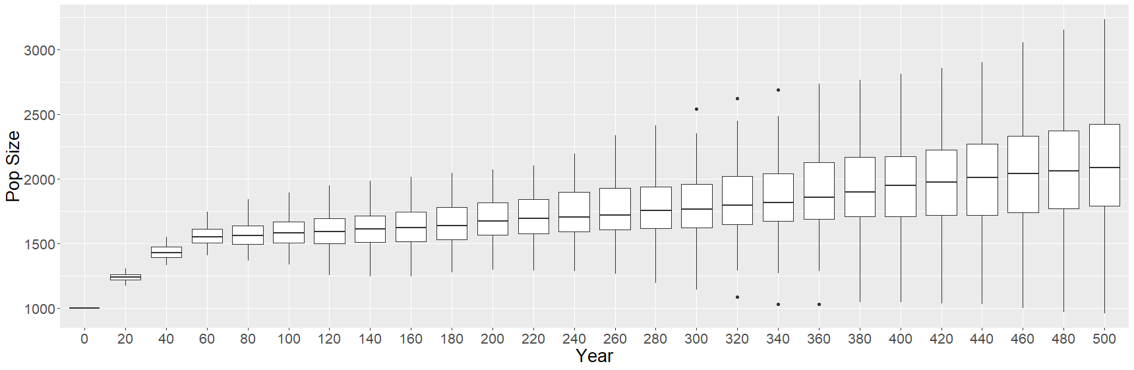

Figure 1 Reference Model

## Religiosity in successful societies

Figure 2 Average Religiosity Values of Successful Societies at year 600

## The effect of stochastic threats

To explore whether stochastic threats had some effect on the models result, we modified the way threats happened in the model while keeping the same parameter space of the 3rd analysis (Table 2 in main MS). We changed the constant yearly increase of threat to (1) a given number of threats per year determined from a Poisson distribution (lambda varied between 0 and 10) and (2) the intensity value of each threat draw from an exponential distribution function (with lambda fixed at 10) (Figure 3). After running the simulations with the stochastic threats implementation, results remained qualitatively the same: percentage of societies with pop sizes > 2500: 31.80%, 79.80%, and 15.72% when the logical order of reproduction was random, before, after PB respectively.

|  |  |
| --- | --- |
| A) | B) |
|  |  |

Figure 3 Stochastic threats. A) Density plot for threat intensity (x-axis), most threats are of low intensity, i.e., <0.25. B) Boxplots of the total threat experienced per year according to different values of lambda (mean number of threats per year)

## The effect of parochial prosociality (PP)

We implemented parochial prosociality (PP) in the model and study its effects on population grow and levels of religiosity. When PP is on, agents performing a PB benefit neighbors only if those neighbors have a religiosity equal or higher to the performing agent’s religiosity - PP value. Thus, the lower the values of PP, the higher the similarity in religiosity needed among agents to receive the benefit of PB. Table 1 shows the parameter space used when exploring the effect of PP.

|  |  |  |
| --- | --- | --- |
|  | MIN | MAX |
| PB threshold | 0.001 | 0.050 |
| PB inc rel self | 0.100 | 0.500 |
| PB inc rel neigh | 0.100 | 0.500 |
| PB dec insec self | 0.250 | 0.500 |
| PB dec insec neigh | 0.250 | 0.500 |
| PB wellbeing cost | 0.001 | 0.025 |
| Num Neigh Benefited | 5 | 10 |
| Threat value | 0.001 | 0.500 |
| Rel Dec Perc | 0.001 | 0.500 |
| Parochial Prosociality | 0.010 | 1.000 |

Table 1 Parameter Space when studying effect of Parochial Prosociality

Results show that PP reduces the % of growing societies, i.e., societies with > 2500 agents at year 600 (Table 2). This is expected because when PP is on, the benefit of PB is received by a lower number of agents and thus the growth of societies is reduced. Indeed, at low values of PP, the percentage of successful societies is lower than expected from the distribution of PP values in the parameter sampling, but as the value of PP increases the percentage of successful societies becomes higher than expected from the parameter sampling (Table 3).

|  |  |  |
| --- | --- | --- |
| Reproduction ocurring | Non-parochial | Parochial Prosociality |
| After | 24.12% | 17.92% |
| Random | 44.96% | 32.46% |
| Before | 74.14% | 53.06% |

Table 2 Percentage of societies with populations > 2500 agents

|  |  |  |  |  |  |  |  |  |  |
| --- | --- | --- | --- | --- | --- | --- | --- | --- | --- |
| PP value range | After | | | Random | | | Before | | |
| % Obs | % Exp | Diff | % Obs | % Exp | Diff | % Obs | % Exp | Diff |
| [0.0-0.1] | 3.27% | 10.00% | -6.73% | 2.58% | 10.00% | -7.42% | 0.65% | 10.00% | -9.35% |
| [0.1-0.2] | 3.64% | 10.00% | -6.36% | 4.39% | 10.00% | -5.61% | 1.47% | 10.00% | -8.53% |
| [0.2-0.3] | 7.64% | 10.00% | -2.36% | 6.21% | 10.00% | -3.79% | 3.54% | 10.00% | -6.46% |
| [0.3-0.4] | 7.27% | 10.00% | -2.73% | 8.18% | 10.00% | -1.82% | 6.02% | 10.00% | -3.98% |
| [0.4-0.5] | 10.18% | 10.00% | 0.18% | 11.82% | 10.00% | 1.82% | 11.50% | 10.00% | 1.50% |
| [0.5-0.6] | 11.27% | 10.00% | 1.27% | 11.06% | 10.00% | 1.06% | 13.57% | 10.00% | 3.57% |
| [0.6-0.7] | 15.27% | 10.00% | 5.27% | 13.18% | 10.00% | 3.18% | 15.93% | 10.00% | 5.93% |
| [0.7-0.8] | 18.55% | 10.00% | 8.55% | 14.09% | 10.00% | 4.09% | 15.46% | 10.00% | 5.46% |
| [0.8-0.9] | 13.09% | 10.00% | 3.09% | 13.79% | 10.00% | 3.79% | 15.63% | 10.00% | 5.63% |
| [0.9-1.0] | 9.82% | 10.00% | -0.18% | 14.70% | 10.00% | 4.70% | 16.22% | 10.00% | 6.22% |

Table 3 Percentage of successful societies Observed and Expected within an specific parameter range of PP

Further, in those societies with PP on and populations above 2500 agents at year 600, the level of average religiosity is much higher than when PP is off (Table 4). It seems, thus, that PP reduces the proportion of successful societies to those with high religiosity.

|  |  |  |  |  |  |  |
| --- | --- | --- | --- | --- | --- | --- |
|  | Non-parochial | | | Parochial Prosociality | | |
|  | Rel > 0.5 | Rel > 0.75 | Rel > 0.9 | Rel > 0.5 | Rel > 0.75 | Rel > 0.9 |
| After | 96.93% | 84.49% | 42.53% | 100.00% | 94.86% | 62.16% |
| Random | 97.50% | 87.36% | 49.28% | 100.00% | 95.68% | 63.03% |
| Before | 98.40% | 85.02% | 39.68% | 99.92% | 87.71% | 40.89% |

Table 4 Successful societies (pop size > 2500) and average religiosity

## CI scheduling

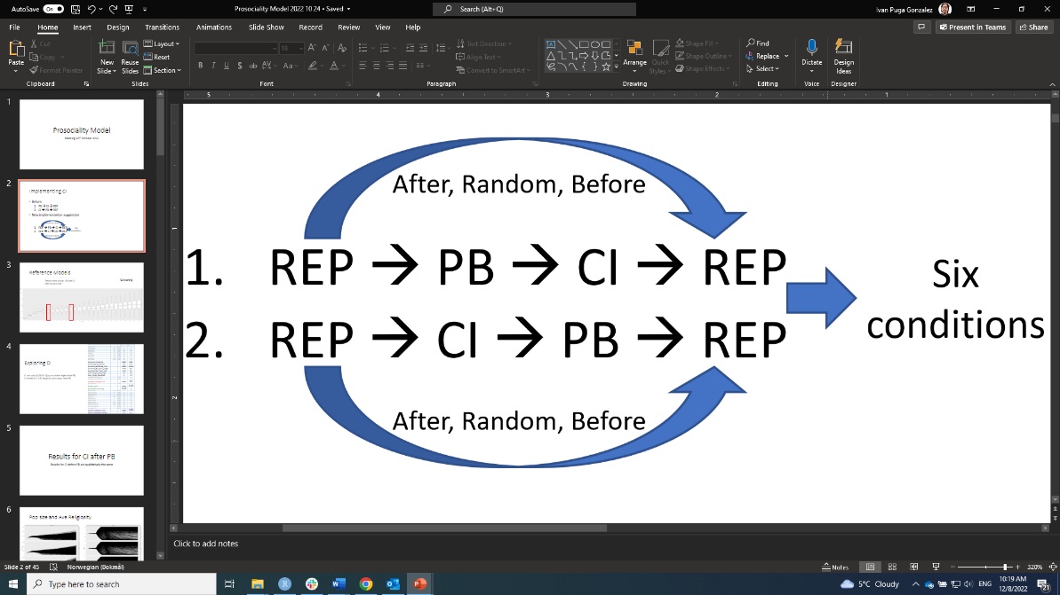

Figure 4 Different schedules of events tried out with CI.

REP, reproduction; PB, prosocial behavior; CI, central institution

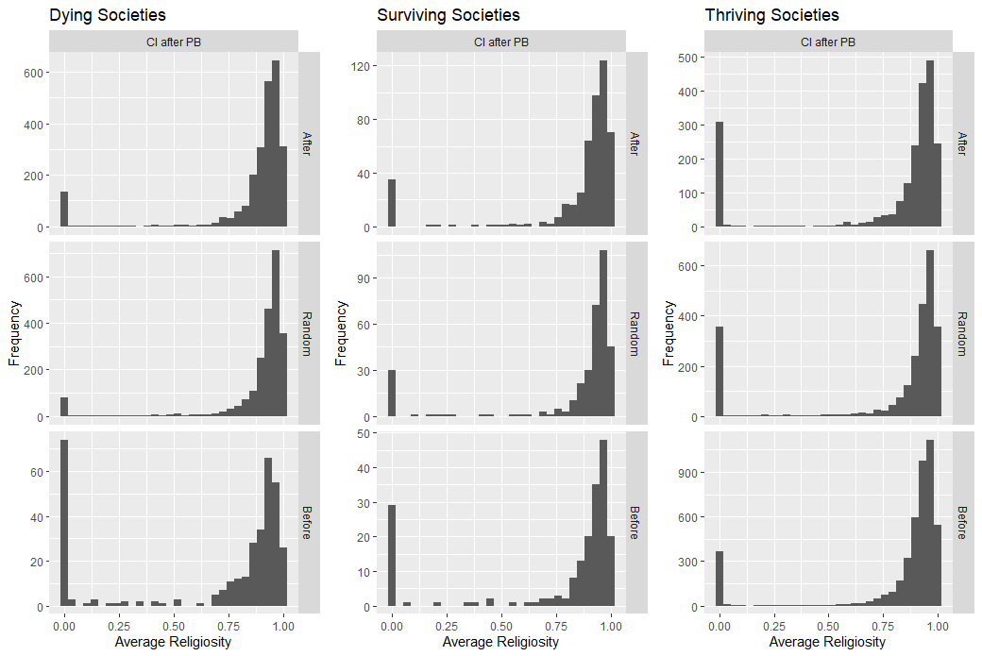

*Figure 5 Average Religiosity at year 600*

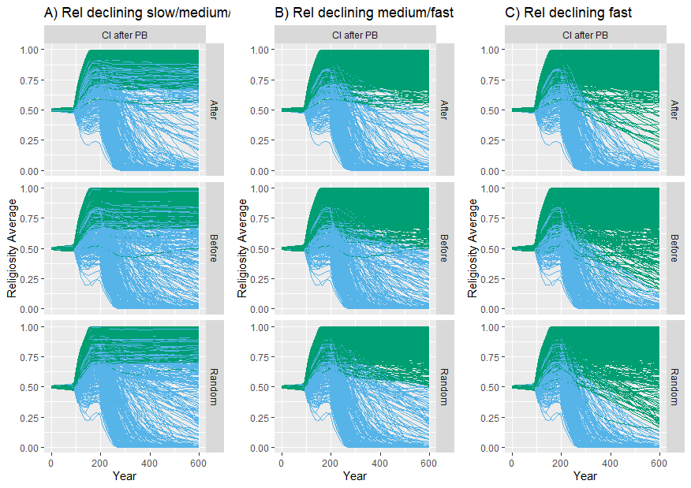

Figure 6 Decline of religiosity at different paces. Blue lines are societies where religiosity was declining during period 200-600 years and were the target of the sensitivity assessor. A) Religiosity declining at a slow/medium/fast pace; B) Religiosity declining at a medium/fast pace; C) Religiosity declining at a fast pace.

|  |  |  |  |  |  |  |  |  |  |
| --- | --- | --- | --- | --- | --- | --- | --- | --- | --- |
|  | **Declining Rel S/M/F** | | | **Declining Rel M/F** | | | **Declining Rel F** | | |
|  | **After** | **Random** | **Before** | **After** | **Random** | **Before** | **After** | **Random** | **Before** |
| **1) Yearly threat** |  | | | | | | | | |
| [0.001 - 0.06] | 47% | 41% | 49% | 63% | 60% | 70% | 64% | 65% | 76% |
| (0.06 - 0.12] | -15% | -12% | -3% | -26% | -25% | -12% | -27% | -28% | -15% |
| (0.12 - 0.18] | -19% | -17% | -15% | -22% | -21% | -20% | -22% | -22% | -21% |
| (0.18 - 0.24] | -9% | -9% | -15% | -10% | -10% | -19% | -10% | -11% | -20% |
| (0.24 - 0.30] | -4% | -4% | -16% | -4% | -4% | -19% | -4% | -4% | -20% |
| **2) Parochial prosociality** |  | | | | | | | | |
| [0.20 - 0.36] | 8% | 12% | 17% | 5% | 6% | 5% | 3% | 3% | 2% |
| (0.36 - 0.52] | -2% | -1% | -3% | -5% | -2% | -2% | -4% | -2% | -4% |
| (0.52 - 0.68] | -1% | 0% | -3% | 3% | 0% | 1% | 3% | 1% | 2% |
| (0.68 - 0.84] | -3% | -5% | -5% | -2% | -3% | -2% | -1% | -1% | 0% |
| (0.84 - 1.00] | -3% | -5% | -6% | -1% | -2% | -2% | -1% | 0% | 0% |
| **3) PB threshold** |  | | | | | | | | |
| [0.001 - 0.01] | -12% | -12% | -13% | -14% | -15% | -15% | -14% | -16% | -15% |
| (0.01 - 0.02] | -4% | -5% | -5% | -5% | -4% | -6% | -5% | -5% | -6% |
| (0.02 - 0.03] | 2% | 3% | 1% | 2% | 0% | 3% | 2% | 2% | 3% |
| (0.03 - 0.04] | 5% | 6% | 6% | 7% | 9% | 7% | 6% | 7% | 7% |
| (0.04 - 0.05] | 9% | 8% | 11% | 9% | 10% | 11% | 10% | 12% | 12% |
| **4) PB WB cost** |  | | | | | | | | |
| [0.001 - 0.005] | -3% | -4% | 1% | -2% | -2% | 3% | -1% | -1% | 3% |
| (0.005 - 0.010] | -5% | -2% | -3% | -9% | -7% | -7% | -10% | -9% | -8% |
| (0.010 - 0.015] | -2% | -1% | -1% | 0% | 1% | 0% | -1% | 1% | 1% |
| (0.015 - 0.020] | 3% | 2% | 1% | 3% | 2% | 1% | 4% | 2% | 1% |
| (0.020 - 0.025] | 8% | 4% | 2% | 9% | 5% | 3% | 8% | 6% | 3% |
| **5) CI benefit** |  | | | | | | | | |
| [0.10 - 0.18] | -7% | -4% | -8% | -12% | -9% | -13% | -12% | -9% | -14% |
| (0.18 - 0.26] | -2% | -2% | -3% | -3% | -3% | -3% | -4% | -4% | -4% |
| (0.26 - 0.34] | 3% | 1% | 2% | 0% | 2% | 3% | 0% | 1% | 3% |
| (0.34 - 0.42] | 3% | 3% | 5% | 6% | 5% | 5% | 6% | 6% | 6% |
| (0.42 - 0.50] | 3% | 2% | 4% | 8% | 6% | 9% | 10% | 6% | 9% |
| **6) CI WB cost** |  | | | | | | | | |
| [0.001 - 0.01] | -1% | -1% | 0% | -3% | -5% | 1% | -3% | -4% | 2% |
| (0.01 - 0.02] | -4% | -4% | -1% | -2% | -3% | -1% | -4% | -4% | -2% |
| (0.02 - 0.03] | -1% | 1% | 1% | -2% | 0% | -1% | -2% | -1% | -1% |
| (0.03 - 0.04] | 1% | 1% | 0% | 0% | 3% | 0% | 1% | 3% | 0% |
| (0.04 - 0.05] | 4% | 4% | -1% | 8% | 5% | 1% | 8% | 6% | 1% |
| **7) Rel Dec Perc** |  | | | | | | | | |
| [0.001 - 0.05] | 0% | -3% | -4% | 1% | -3% | -2% | 1% | -2% | -1% |
| (0.05 - 0.10] | -4% | -5% | -6% | -3% | -4% | -3% | -1% | -1% | -1% |
| (0.10 - 0.15] | 0% | 0% | -3% | 2% | 2% | -1% | 2% | 2% | -1% |
| (0.15 - 0.20] | 2% | 2% | 5% | 0% | 3% | 3% | 0% | 1% | 3% |
| (0.20 - 0.25] | 1% | 6% | 8% | -1% | 2% | 3% | -2% | 0% | -1% |

*Table 5 Percentage difference (Observed – Expected) of societies with declining religiosity at different paces and within a specific parameter range. Color scale goes from dark yellow (negative) to dark green (positive). Positive (dark green) values mean that more TSDR were present than expected and vice versa for negative (dark yellow) values. Note that the color scale is adjusted to the percentage range within each parameter.*

|  |  |  |  |  |  |  |  |  |  |  |  |  |
| --- | --- | --- | --- | --- | --- | --- | --- | --- | --- | --- | --- | --- |
|  | **Declining Rel S/M/F** | | | **Declining Rel M/F** | | | **Declining Rel F** | | | | | |
| **CONDITIONS** | **After** | **Random** | **Before** | **After** | **Random** | **Before** | | **After** | **Random** | | **Before** | |
| **1) Yearly threat AND PB threshold** |  |  |  |  |  |  | |  |  | |  | |
| Lower half AND Lower half | -6% | -6% | 3% | -8% | -9% | 3% | | -8% | -9% | | 3% | |
| Lower half AND Upper half | 27% | 26% | 36% | 33% | 33% | 45% | | 32% | 34% | | 48% | |
| Upper half AND Lower half | -10% | -10% | -21% | -12% | -13% | -25% | | -12% | -13% | | -25% | |
| Upper half AND Upper half | -11% | -10% | -18% | -13% | -11% | -23% | | -13% | -12% | | -25% | |
| **2) Yearly threat AND PB WB cost** |  |  |  |  |  |  | |  |  | |  | |
| Lower half AND Lower half | 5% | 8% | 18% | 4% | 6% | 20% | | 3% | 6% | | 20% | |
| Lower half AND Upper half | 16% | 12% | 21% | 21% | 17% | 28% | | 22% | 18% | | 30% | |
| Upper half AND Lower half | -15% | -14% | -21% | -17% | -16% | -26% | | -17% | -17% | | -27% | |
| Upper half AND Upper half | -6% | -6% | -18% | -7% | -8% | -23% | | -7% | -8% | | -24% | |
| **3) Yearly threat AND Rel Dec Perc** |  |  |  |  |  |  | |  |  | |  | |
| Lower half AND Lower half | 9% | 4% | 14% | 13% | 6% | 20% | | 14% | 11% | | 24% | |
| Lower half AND Upper half | 12% | 16% | 25% | 12% | 17% | 28% | | 10% | 14% | | 27% | |
| Upper half AND Lower half | -12% | -12% | -25% | -12% | -13% | -25% | | -12% | -13% | | -25% | |
| Upper half AND Upper half | -9% | -8% | -14% | -12% | -11% | -24% | | -12% | -12% | | -26% | |
| **4) Yearly threat AND Parochial Prosociality** |  |  |  |  |  |  | |  |  | |  | |
| Lower half AND Lower half | 17% | 18% | 27% | 14% | 14% | 28% | | 13% | 13% | | 25% | |
| Lower half AND Upper half | 5% | 2% | 12% | 10% | 9% | 21% | | 11% | 12% | | 25% | |
| Upper half AND Lower half | -9% | -7% | -14% | -12% | -11% | -23% | | -12% | -12% | | -25% | |
| Upper half AND Upper half | -12% | -13% | -25% | -12% | -13% | -25% | | -12% | -13% | | -25% | |
| **5) Yearly threat AND CI WB cost** |  |  |  |  |  |  | |  |  | |  | |
| Lower half AND Lower half | 11% | 11% | 19% | 13% | 10% | 25% | | 11% | 11% | | 26% | |
| Lower half AND Upper half | 10% | 10% | 20% | 11% | 13% | 23% | | 13% | 14% | | 24% | |
| Upper half AND Lower half | -17% | -15% | -20% | -19% | -19% | -26% | | -19% | -19% | | -27% | |
| Upper half AND Upper half | -4% | -5% | -19% | -5% | -5% | -23% | | -5% | -5% | | -23% | |
| **6) Yearly threat AND CI benefit** |  |  |  |  |  |  | |  |  | |  | |
| Lower half AND Lower half | 0% | 1% | 12% | -7% | -4% | 7% | | -8% | -4% | | 7% | |
| Lower half AND Upper half | 21% | 20% | 27% | 31% | 28% | 42% | | 32% | 29% | | 44% | |
| Upper half AND Lower half | -7% | -5% | -21% | -7% | -6% | -23% | | -7% | -6% | | -23% | |
| Upper half AND Upper half | -14% | -15% | -18% | -17% | -18% | -26% | | -17% | -19% | | -28% | |
| **7) PB threshold AND PB WB cost** |  |  |  |  |  |  | |  |  | |  | |
| Lower half AND Lower half | -13% | -11% | -11% | -18% | -17% | -15% | | -19% | -18% | | -16% | |
| Lower half AND Upper half | -3% | -5% | -7% | -2% | -4% | -7% | | -1% | -4% | | -6% | |
| Upper half AND Lower half | 3% | 5% | 8% | 5% | 8% | 10% | | 5% | 8% | | 9% | |
| Upper half AND Upper half | 13% | 11% | 10% | 15% | 14% | 12% | | 15% | 14% | | 13% | |
| **8) PB threshold AND Rel Dec Perc** |  |  |  |  |  |  | |  |  | |  | |
| Lower half AND Lower half | -11% | -13% | -15% | -10% | -13% | -12% | | -10% | -11% | | -11% | |
| Lower half AND Upper half | -5% | -3% | -3% | -10% | -9% | -10% | | -10% | -11% | | -12% | |
| Upper half AND Lower half | 8% | 5% | 4% | 11% | 7% | 8% | | 12% | 9% | | 9% | |
| Upper half AND Upper half | 8% | 11% | 14% | 9% | 15% | 14% | | 8% | 13% | | 13% | |
| **9) PB threshold AND Parochial Prosociality** |  |  |  |  |  |  | |  |  | |  | |
| Lower half AND Lower half | -1% | 0% | -2% | -6% | -7% | -8% | | -7% | -9% | | -10% | |
| Lower half AND Upper half | -15% | -16% | -16% | -14% | -15% | -14% | | -13% | -13% | | -12% | |
| Upper half AND Lower half | 9% | 11% | 15% | 8% | 11% | 12% | | 8% | 10% | | 9% | |
| Upper half AND Upper half | 7% | 5% | 3% | 12% | 11% | 10% | | 12% | 12% | | 13% | |
| **10) PB threshold AND CI WB cost** |  |  |  |  |  |  | |  |  | |  | |
| Lower half AND Lower half | -13% | -11% | -9% | -15% | -15% | -11% | | -15% | -15% | | -12% | |
| Lower half AND Upper half | -4% | -5% | -9% | -5% | -7% | -11% | | -4% | -7% | | -11% | |
| Upper half AND Lower half | 7% | 6% | 9% | 8% | 6% | 11% | | 7% | 7% | | 11% | |
| Upper half AND Upper half | 9% | 10% | 9% | 12% | 15% | 11% | | 13% | 16% | | 11% | |
| **11) PB threshold AND CI benefit** |  |  |  |  |  |  | |  |  | |  | |
| Lower half AND Lower half | -9% | -8% | -11% | -10% | -9% | -12% | | -11% | -10% | | -13% | |
| Lower half AND Upper half | -7% | -8% | -7% | -10% | -12% | -10% | | -9% | -12% | | -9% | |
| Upper half AND Lower half | 2% | 4% | 2% | -4% | 0% | -4% | | -5% | 0% | | -3% | |
| Upper half AND Upper half | 14% | 13% | 16% | 24% | 22% | 26% | | 25% | 23% | | 25% | |
| **12) PB WB cost AND Rel Dec Perc** |  |  |  |  |  |  | |  |  | |  | |
| Lower half AND Lower half | -7% | -8% | -8% | -8% | -10% | -7% | | -9% | -9% | | -7% | |
| Lower half AND Upper half | -2% | 2% | 6% | -5% | 0% | 1% | | -6% | -1% | | 0% | |
| Upper half AND Lower half | 5% | 0% | -3% | 9% | 4% | 2% | | 10% | 7% | | 5% | |
| Upper half AND Upper half | 5% | 6% | 5% | 4% | 6% | 3% | | 4% | 3% | | 2% | |
| **13) PB WB cost AND Parochial Prosociality** |  |  |  |  |  |  | |  |  | |  | |
| Lower half AND Lower half | 1% | 3% | 5% | -5% | -4% | -1% | | -7% | -7% | | -5% | |
| Lower half AND Upper half | -10% | -9% | -8% | -8% | -5% | -4% | | -7% | -4% | | -2% | |
| Upper half AND Lower half | 7% | 9% | 8% | 8% | 8% | 6% | | 8% | 8% | | 5% | |
| Upper half AND Upper half | 3% | -3% | -6% | 5% | 2% | 0% | | 6% | 3% | | 2% | |
| **14) PB WB cost AND CI WB cost** |  |  |  |  |  |  | |  |  | |  | |
| Lower half AND Lower half | -8% | -5% | 0% | -9% | -8% | -1% | | -11% | -9% | | -2% | |
| Lower half AND Upper half | -2% | -1% | -2% | -4% | -1% | -4% | | -3% | -2% | | -5% | |
| Upper half AND Lower half | 2% | 1% | -1% | 2% | 0% | 1% | | 3% | 0% | | 2% | |
| Upper half AND Upper half | 7% | 5% | 3% | 11% | 10% | 5% | | 12% | 10% | | 5% | |
| **15) PB WB cost AND CI benefit** |  |  |  |  |  |  | |  |  | |  | |
| Lower half AND Lower half | -8% | -6% | -5% | -10% | -7% | -8% | | -11% | -8% | | -9% | |
| Lower half AND Upper half | -2% | 0% | 3% | -3% | -2% | 3% | | -3% | -3% | | 2% | |
| Upper half AND Lower half | 0% | 1% | -4% | -5% | -3% | -8% | | -5% | -3% | | -7% | |
| Upper half AND Upper half | 9% | 5% | 6% | 18% | 12% | 13% | | 19% | 13% | | 14% | |
| **16) Rel Dec Perc AND Parochial Prosociality** | | | | | | | | | |  | |  |
| Lower half AND Lower half | -1% | -3% | -5% | 2% | -2% | -1% | | 1% | -1% | | 0% | |
| Lower half AND Upper half | -1% | -6% | -6% | -1% | -4% | -4% | | 1% | -1% | | -2% | |
| Upper half AND Lower half | 9% | 14% | 19% | 1% | 6% | 5% | | 0% | 2% | | -1% | |
| Upper half AND Upper half | -6% | -6% | -8% | -1% | 0% | 0% | | -2% | 0% | | 2% | |
| **17) Rel Dec Perc AND CI WB cost** |  |  |  |  |  |  | |  |  | |  | |
| Lower half AND Lower half | -6% | -7% | -6% | -3% | -6% | -2% | | -3% | -4% | | 0% | |
| Lower half AND Upper half | 3% | -1% | -5% | 4% | 0% | -3% | | 5% | 2% | | -1% | |
| Upper half AND Lower half | 0% | 2% | 6% | -4% | -3% | 1% | | -5% | -5% | | -1% | |
| Upper half AND Upper half | 3% | 6% | 5% | 3% | 9% | 3% | | 4% | 7% | | 2% | |
| **18) Rel Dec Perc AND CI benefit** |  |  |  |  |  |  | |  |  | |  | |
| Lower half AND Lower half | -4% | -5% | -7% | -6% | -7% | -9% | | -6% | -6% | | -8% | |
| Lower half AND Upper half | 1% | -3% | -4% | 7% | 1% | 5% | | 8% | 4% | | 7% | |
| Upper half AND Lower half | -3% | 0% | -2% | -8% | -2% | -7% | | -9% | -4% | | -8% | |
| Upper half AND Upper half | 6% | 8% | 13% | 8% | 8% | 11% | | 8% | 6% | | 9% | |
| **19) Parochial Prosociality AND CI WB cost** |  |  |  |  |  |  | |  |  | |  | |
| Lower half AND Lower half | 4% | 6% | 8% | -3% | -2% | 2% | | -4% | -4% | | -1% | |
| Lower half AND Upper half | 4% | 5% | 6% | 5% | 6% | 2% | | 6% | 5% | | 1% | |
| Upper half AND Lower half | -10% | -11% | -8% | -4% | -6% | -2% | | -4% | -5% | | 1% | |
| Upper half AND Upper half | 2% | 0% | -5% | 2% | 3% | -2% | | 3% | 4% | | 0% | |
| **20) Parochial Prosociality AND CI benefit** |  |  |  |  |  |  | |  |  | |  | |
| Lower half AND Lower half | -2% | 1% | -1% | -7% | -5% | -8% | | -8% | -6% | | -9% | |
| Lower half AND Upper half | 9% | 10% | 15% | 10% | 9% | 12% | | 9% | 7% | | 9% | |
| Upper half AND Lower half | -5% | -6% | -8% | -7% | -5% | -8% | | -8% | -4% | | -6% | |
| Upper half AND Upper half | -2% | -6% | -5% | 5% | 1% | 4% | | 7% | 3% | | 7% | |
| **21) CI WB cost AND CI benefit** |  |  |  |  |  |  | |  |  | |  | |
| Lower half AND Lower half | -5% | -3% | -6% | -9% | -6% | -8% | | -10% | -8% | | -7% | |
| Lower half AND Upper half | 0% | -1% | 5% | 2% | -2% | 7% | | 2% | -1% | | 7% | |
| Upper half AND Lower half | -2% | -1% | -4% | -5% | -3% | -8% | | -5% | -3% | | -8% | |
| Upper half AND Upper half | 8% | 6% | 4% | 12% | 12% | 8% | | 13% | 11% | | 9% | |

Table 6 Percentage difference (Observed – Expected) of societies with declining religiosity at different paces and within a specific combination of parameters range. Color scale goes from dark yellow (negative) to dark green (positive). Positive (dark green) values mean that more TSDR were present than expected and vice versa for negative (dark yellow) values. Note that the color scale is adjusted to the percentage range within each combination of parameters.